Inversion of Control (IoC) & Spring Container
Before understanding Inversion of Control, we must first understand control itself.
1️⃣ What Do We Mean by “Control”?
In traditional Java applications:
- Classes decide what objects to create
- Classes decide when to create them
- Classes manage lifecycle and cleanup
This may feel normal — but it is the root cause of tight coupling.

2️⃣ The Core Misunderstanding (Very Common)
Many developers think:
“Tight coupling exists only when I have multiple implementations
(Airtel, Jio, Idea).
If I have only one class, why worry?”
This sounds logical — but it’s incomplete.

3️⃣ What Tight Coupling Actually Means
Tight coupling is NOT about number of classes.
It is about who controls object creation.
Tight Coupling
→ This class decides what concrete dependency it will use.
Loose Coupling
→ This class does NOT decide. Someone else provides the dependency.
Even one single class can be tightly coupled.

4️⃣ Single-Class Example (Very Important)
Case 1: Without DI (Tight Coupling)
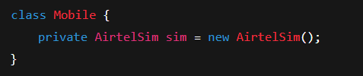
You might say:
“There’s only Airtel. What’s the issue?”
Hidden Problems:
- Mobile is tied to AirtelSim
- Cannot test Mobile independently
- Cannot replace AirtelSim without code change
- Mobile controls creation (violates SRP)
- Any future change requires recompilation & redeployment
This is tight coupling, even with one class.

5️⃣ Why This Becomes Dangerous in Real Projects
Today:
- Only AirtelSim
Tomorrow:
- Needs database
- Needs API calls
- Needs caching
- Needs mocks for testing
Now every change forces:
- Code modification
- Rebuild
- Retest
- Redeploy
That’s fragile architecture.

6️⃣ Same Scenario with Dependency Injection (Loose Coupling)
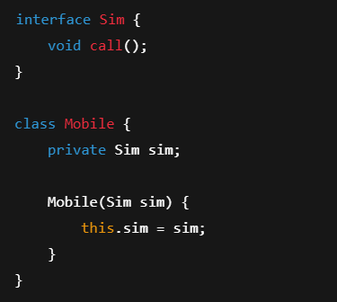
Now:
- Mobile depends on abstraction
- Creation happens outside
- Mobile has zero knowledge of concrete class
Even with one implementation today, you gain:
- Testability
- Replaceability
- Clean architecture
- SRP compliance
- Future safety

7️⃣ Real-Life Analogy
Tight Coupling (Even with One Option)
- SIM is soldered inside phone
- Cannot replace
- Cannot test without it
- Bad design
Loose Coupling (DI)
- Phone has SIM slot
- Even if only Airtel exists today
- Design is still correct
- Phone is future-proof

8️⃣ Why Spring Enforces DI Even with One Class
Spring is not solving today’s problem.
Spring is solving tomorrow’s change.
Spring assumes:
- Requirements will change
- Testing will be needed
- Implementations will grow
- Production issues will happen
So Spring enforces:
- Constructor injection
- Interface-driven design
- External wiring
Not for convenience — for survivability.

9️⃣ Interview-Grade One-Liner
“Tight coupling is not about how many implementations exist.
It’s about who controls object creation.
Dependency Injection removes that control from the class.”

🔁 Transition to Inversion of Control (IoC)
So far we said:
- Objects should be created outside
- Dependencies should be injected
Now the real question:
👉 Who does this creation and wiring?

0️⃣ Inversion of Control (IoC)
Inversion of Control means:
The responsibility of creating, wiring, and managing objects
is moved from the application to an external framework.
In Spring:
- That external framework is Spring itself
DI is the mechanism
IoC is the principle

1️⃣ Spring Container — The Heart of IoC
The Spring Container:
- Creates beans
- Injects dependencies
- Manages lifecycle
- Destroys beans
You give classes.
Spring gives fully wired objects.
2️⃣ Configuration Metadata — How Spring Knows What to Do
Spring needs instructions.
These instructions are called Configuration Metadata.
You can provide them via:
- XML configuration
- Annotations
- Java-based configuration
This metadata tells Spring:
- What to create
- How to configure
- How to assemble dependencies

3️⃣ Types of Spring Containers
BeanFactory
- Lightweight
- Lazy initialization
- Suitable for simple apps
ApplicationContext
- Enterprise-ready
- Eager initialization
- Event handling, AOP, i18n
➡ Used in real-world applications.

4️⃣ DI in Layered Architecture (Enterprise View)
In a typical backend system:
- Controller → depends on Service
- Service → depends on Repository
- Repository → depends on DataSource
Spring injects dependencies across all layers, ensuring:
- Loose coupling
- Testability
- Maintainability

🔚 Final Takeaway
- DI removes object creation
- IoC removes ownership
- Spring Container manages everything in between

